Regulatory Committee
Meeting to be held on 9th March 2022

Part I

Electoral Division affected:
Whitworth and Bacup

Wildlife and Countryside Act 1981
Definitive Map Modification Order Investigation
Addition of a Footpath along Whitworth Rise, Whitworth
(Annex ‘A’ refers)

Contact for further information quoting the reference number 804-643:
Simon Moore, 01772 531280, Paralegal Officer, County Secretary and Solicitors Group, simon.moore@lancashire.gov.uk
Jayne Elliott, 01772 537663, Public Rights of Way Definitive Map Officer, Environment and Planning Group, jayne.elliott@lancashire.gov.uk

Brief Summary

Application for the addition of a footpath to the Definitive Map and Statement of Public Rights of Way from Market Street to Stoneyroyd via Whitworth Rise, Whitworth, Rossendale.

Recommendation

That an Order be made pursuant to Section 53(2)(b), Section 53(3)(b) and Section 53(3)(c)(i) of the Wildlife and Countryside Act 1981 to record a footpath on the Definitive Map and Statement of Public Rights of Way from Market Street to Stoneyroyd as shown on Committee Plan between points A-B-C-D.

That being satisfied that the higher test for confirmation can be met the Order be promoted to confirmation.

Detail

An application has been received to record a public footpath on the Definitive Map and Statement of Public Rights of Way along Whitworth Rise, Whitworth in the Borough of Rossendale.

The county council is required by law to investigate the evidence and make a decision based on that evidence as to whether a public right of way exists, and if so its status. Section 53(3)(b) and (c) of the Wildlife and Countryside Act 1981 set out the tests that need to be met when reaching a decision; also current Case Law needs to be applied.

An order will only be made to add a public right of way to the Definitive Map and Statement if the evidence shows that:
- A right of way “subsists” or is “reasonably alleged to subsist”

An order for adding a way to or upgrading a way shown on the Definitive Map and Statement will be made if the evidence shows that:
- “the expiration… of any period such that the enjoyment by the public…raises a presumption that the way has been dedicated as a public path or restricted byway”

When considering evidence, if it is shown that a highway existed then highway rights continue to exist (“once a highway, always a highway”) even if a route has since become disused or obstructed unless a legal order stopping up or diverting the rights has been made. Section 53 of the Wildlife and Countryside Act 1981 makes it clear that considerations such as suitability, the security of properties and the wishes of adjacent landowners cannot be considered. The Planning Inspectorate’s website also gives guidance about the interpretation of evidence.

The county council’s decision will be based on the interpretation of the evidence discovered by officers and documents and other evidence supplied by the applicant, landowners, consultees and other interested parties produced to the county council before the date of the decision. Each piece of evidence will be tested and the evidence overall weighed on the balance of probabilities. It is possible that the council’s decision may be different from the status given in any original application. The decision may be that the routes have public rights as a footpath, bridleway, restricted byway or byway open to all traffic, or that no such right of way exists. The decision may also be that the routes to be added or deleted vary in length or location from those that were originally considered.

Consultations

Rossendale Borough Council

Rossendale Borough Council provided no response to consultation.

Whitworth Town Council

Whitworth Town Council provided no response to consultation.

Applicant/Landowners/Supporters/Objectors

The evidence submitted by the applicant/landowners/supporters/objectors and observations on those comments are included in Advice – Head of Service – Legal and Democratic Services Observations.

Advice

Head of Service – Planning and Environment

Points annotated on the attached Committee plan.

Point | Grid Reference (SD) | Description
A | 8868 1842 | Open junction with Market Street
B | 8872 1842 | South end of passage between buildings
C | 8872 1842 | North end of passage between buildings
D | 8872 1843 | Open junction with Stoneyroyd

Description of Route

A site inspection was carried out in April 2021.

The application route starts at a point on Market Street, Whitworth between 554 Market Street and 1 Whitworth Rise (point A on the Committee plan).

The route is approximately 3.5 metres wide and tarmacked with a street sign indicating that is known as Whitworth Rise.

The route ascends along the tarmac road in an east south easterly direction providing direct access to properties 1,3 and 3 Whitworth Rise on the south side of the route and to a tarmacked area used to park cars. A sign close to point A indicates that parking is private. On the north side of the route there is access into the side of the property numbered 554 Market Street and to the rear is a building on which there is a sign saying 'Citizens Advice Bureau' but which now appears to have been converted into residential properties.

Just past 3 Whitworth Rise the application route curves northwards to continue across the tarmac area used for parking to point B at the rear of the former Citizens Advice Bureau building. From point B the route continues for approximately 5 metres between the former Citizens Advice Bureau building and a garage accessed from Stoneyroyd along a tarmac strip bounded by the buildings and measuring approximately 0.5 metres wide. At point C the route ascends some concrete steps and continues for a further 7 metres along a flagged footway adjacent to a recently erected wooden fence to exit onto Stoneyroyd at point D.

The total length of the route is approximately 50 metres.

The fence and gate referred to by the applicant as having been erected and obstructing the route in 2020 were no longer in place and access along the full length of the route was available when inspected in April 2021.

The concrete steps have been properly formed presumably by an owner. These steps make it easier, or perhaps make it possible, for people to pass along this section of the application route.

Map and Documentary Evidence

A variety of maps, plans and other documents were examined to discover when the route came into being, and to try to determine what its status may be.

Document Title | Date | Brief Description of Document & Nature of Evidence
Yates’ Map  of Lancashire | 1786 | Small scale commercial map. Such maps were on sale to the public and hence to be of use to their customers the routes shown had to be available for the public to use. However, they were privately produced without a known system of consultation or checking. Limitations of scale also constrained the routes that could be shown.
Observations |  | The application route is not shown.
Greenwood’s Map of Lancashire | 1818 | Small scale commercial map. In contrast to other map makers of the era Greenwood stated in the legend that this map showed private as well as public roads and the two were not differentiated between within the key panel.
Observations |  | The application route is not shown.
Hennet's Map of Lancashire | 1830 | Small scale commercial map. In 1830 Henry Teesdale of London published George Hennet's Map of Lancashire surveyed in 1828-1829 at a scale of 71/2 inches to 1 mile. Hennet's finer hachuring was no more successful than Greenwood's in portraying Lancashire's hills and valleys but his mapping of the county's communications network was generally considered to be the clearest and most helpful that had yet been achieved.
Observations |  | The application route is not shown.
Investigating Officer's Comments on the early commercial maps detailed above |  | The application route is not shown on any of the early commercial maps examined suggesting that it did not exist as a major route at the time. It may have existed as a minor route but due to the limitations of scale would not have been shown so no inference can be drawn in this respect.
Canal and Railway Acts |  | Canals and railways were the vital infrastructure for a modernising economy and hence, like motorways and high speed rail links today, legislation enabled these to be built by compulsion where agreement couldn't be reached. It was important to get the details right by making provision for any public rights of way to avoid objections but not to provide expensive crossings unless they really were public rights of way. This information is also often available for proposed canals and railways which were never built.
Observations |  | There are no existing or proposed canals or railways affecting the land crossed by the application route.
Investigating Officer's Comments |  | No inference can be drawn.
Tithe Map and Tithe Award or Apportionment | 1845 | Maps and other documents were produced under the Tithe Commutation Act of 1836 to record land capable of producing a crop and what each landowner should pay in lieu of tithes to the church. The maps are usually detailed large scale maps of a parish and while they were not produced specifically to show roads or public rights of way, the maps do show roads quite accurately and can provide useful supporting evidence (in conjunction with the written tithe award) and additional information from which the status of ways may be inferred.
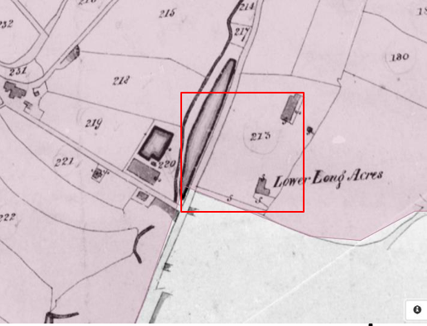
Observations |  | The Tithe Map of Spotland covers the area crossed by the application route. Market Street is shown but Whitworth Rise and Stoneyroyd are not shown and the land crossed by the application route is a plot of land numbered 273 which was listed as being owned by Thomas William Lloyd and occupied by Abram Hill.
Investigating Officer's Comments |  | The application route did not exist in 1845.
Inclosure Act Award and Maps |  | Inclosure Awards are legal documents made under private acts of Parliament or general acts (post 1801) for reforming medieval farming practices, and also enabled new rights of way layouts in a parish to be made. They can provide conclusive evidence of status.
Observations |  | There are no Inclosure Award records for the area containing the application route deposited at the County Records Office.
Investigating Officer's Comments |  | No inference can be drawn.
6 Inch Ordnance Survey (OS) Map  Sheet 80 | 1851 | The earliest Ordnance Survey 6 inch map for this area surveyed in 1844 to 1848 and published in 1851.
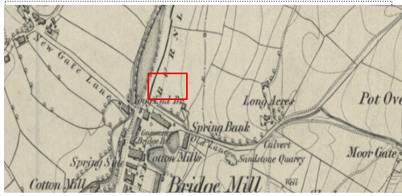
Observations |  | The application route is not shown. The land over which it runs is part of a field east of the Turnpike Road.
Investigating Officer's Comments |  | The application route did not exist at the time of the OS survey (1844-48).
25 Inch OS Map  Sheet 80.8 | 1893 | The earliest OS map at a scale of 25 inch to the mile. Surveyed in 1891 and published in 1893.
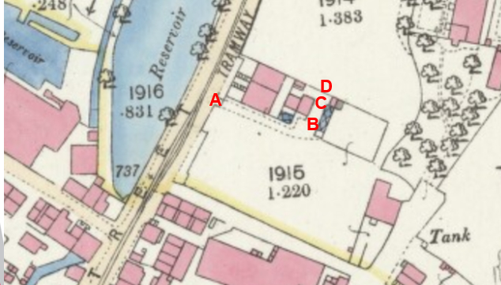
Observations |  | A route is shown marked by dashed lines consistent with the application route between point A and point B. From point B through to point D there is a wide strip of land between buildings. A building on the same footprint as the current building abutting the north west side of the application route between point B and point C is shown but there is a wide gap and access is not restricted to a narrow accessway as it is now. At point D a line is shown across the end of the application route and Stoneyroyd is not shown. At point A a solid line is also shown across the start of the route.
Investigating Officer's Comments |  | The application route existed in 1891 although the available width was much wider than it is today between point B and point C.  The route may have been gated at point A although it is not clear whether a gate or some other form of access restriction would have been locked or closed at that time. A line is also shown across the route at point D and there is no evidence on the map of a route extending beyond point D suggesting that the line at point D was more likely to be a fence or wall.  The existence of the buildings in proximity to the route and the fact that the route did not exist on earlier maps examined suggests that the route was constructed as access to the buildings and not as a through route. Whilst the route may have been accessible it is unlikely that it was used as a public route at that time.
25 inch OS Map  Sheet 80-8 | 1910 | Further edition of the 25 inch map surveyed in 1891, revised in 1909 and published in 1910.
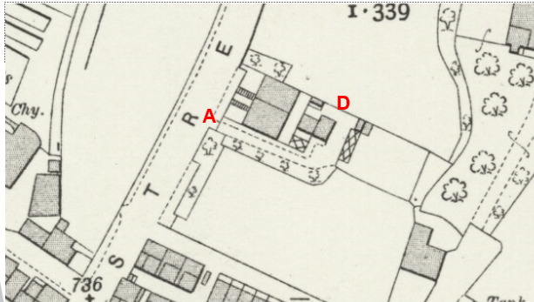
Observations |  | The application route is shown in the same way as it is shown on the earlier 25 inch OS map detailed above.
Investigating Officer's Comments |  | The application route existed in 1909 but was unlikely to be used as a public through route and did not provide access to a place of public interest at or from point D.
Finance Act 1910 Map | 1910 | The comprehensive survey carried out for the Finance Act 1910, later repealed, was for the purposes of land valuation not recording public rights of way but can often provide very good evidence. Making a false claim for a deduction was an offence although a deduction did not have to be claimed so although there was a financial incentive a public right of way did not have to be admitted.  Maps, valuation books and field books produced under the requirements of the 1910 Finance Act have been examined. The Act required all land in private ownership to be recorded so that it could be valued and the owner taxed on any incremental value if the land was subsequently sold. The maps show land divided into parcels on which tax was levied, and accompanying valuation books provide details of the value of each parcel of land, along with the name of the owner and tenant (where applicable).  An owner of land could claim a reduction in tax if his land was crossed by a public right of way and this can be found in the relevant valuation book. However, the exact route of the right of way was not recorded in the book or on the accompanying map. Where only one path was shown by the Ordnance Survey through the landholding, it is likely that the path shown is the one referred to, but we cannot be certain. In the case where many paths are shown, it is not possible to know which path or paths the valuation book entry refers to. It should also be noted that if no reduction was claimed this does not necessarily mean that no right of way existed.
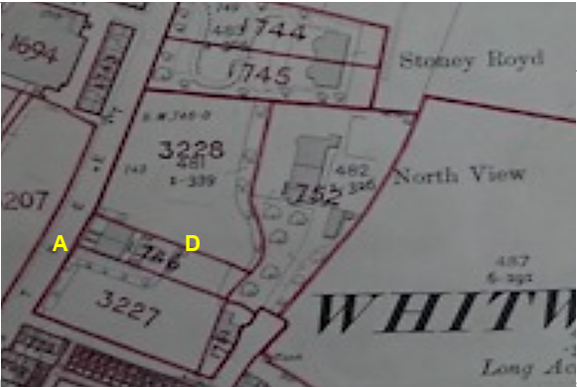
Observations |  | The application route was not excluded from the numbered plots but is shown as part of plot 3227 and 786. No deductions are made for public rights of way or user for either of the numbered plots.
Investigating Officer's Comments |  | It appears that in the early 1900s the owners of the land crossed by the application route did not acknowledge the existence of any public rights over the land at the time of the valuation.
25 Inch OS Map | 1929 | Further edition of 25 inch map (surveyed 1891, revised in 1928 and published 1929.
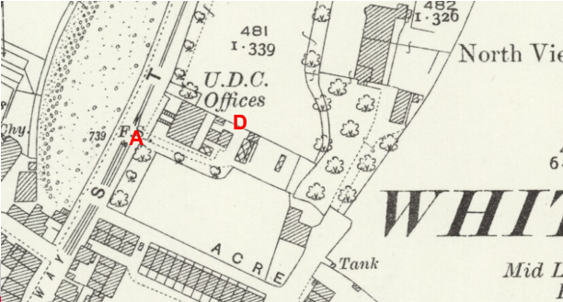
Observations |  | The application route is shown in the same way as it is on earlier editions of the 25 inch OS mapping. The buildings accessed by the route are labelled as Urban District Council Offices. No ongoing route beyond point D is shown.
Investigating Officer's Comments |  | The application route existed in 1928 but was unlikely to be used as a public through route. It may have been used as access to the Urban District Council Offices although these were more likely to have been accessed by the public direct from Market Street itself.
6 Inch OS Map | 1956 | The OS base map for the Definitive Map, First Review, was published in 1956 at a scale of 6 inches to 1 mile (1:10,560). This map was revised before 1930 and is probably based on the same survey as the 1930s 25-inch map.
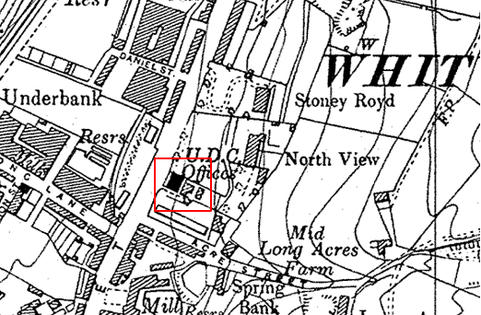
Observations |  | The smaller scale 6 inch OS map shows access available along the side of the UDC Offices consistent with the application route but does not show a through route continuing from the boundary of the property at point D.
Investigating Officer's Comments |  | The application route probably did not exist as a public route in the 1930s.
1:2500 OS Map  Sheet SD8818-8918 | 1964 | Further edition of 25 inch map reconstituted from former county series and revised in 1962 and published 1964 as national grid series.
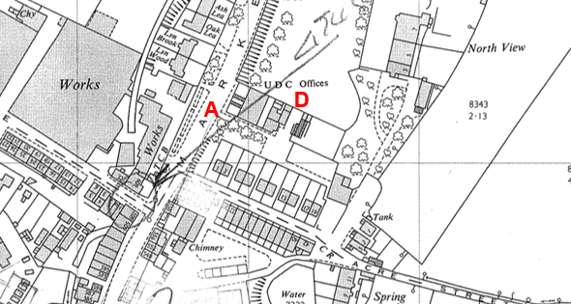
Observations |  | The application route is again shown in the same way as it is on earlier editions of the 25 inch OS mapping. The buildings accessed by the route are still labelled as Urban District Council Offices. No ongoing route beyond point D is shown.
Investigating Officer's Comments |  | Access between point A and point D appears to be available but the map provides no evidence of a through route beyond point D.
1:2500 OS Map  Sheet SD8818-8918 | 1970 | Further edition of 25 inch map reconstituted from former county series revised and published in 1970 as national grid series.
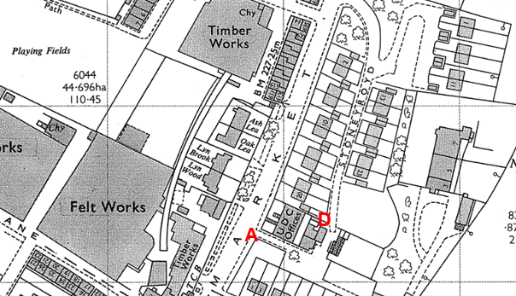
Observations |  | The application route is again shown in the same way as it is on earlier editions of the 25 inch OS mapping. The buildings accessed by the route are labelled as UDC Offices. Stoneyroyd is shown on the map with houses built along it. The southern end of Stoneyroyd is shown leading into the area at the rear of the UDC Offices at point D.
Investigating Officer's Comments |  | By 1970 a through route existed from Market Street to Stoneyroyd which appeared to be capable of being used.
Undated plan submitted by applicant | c.1970
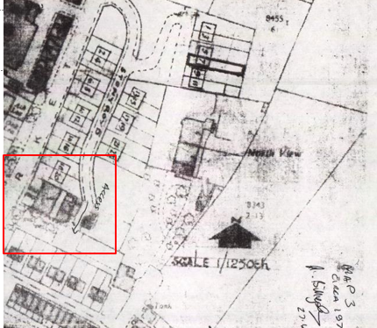
Observations |  | The applicant submitted a plan which he described as dating from circa 1970 which showed access from Stoneyroyd through to Market Street. The plan is undated and appears to have been reproduced from a 1:1250 OS map with Stoneyroyd and the houses built along Stoneyroyd drawn onto it. The word 'Access' and arrow pointing from Stoneyroyd along the application route have been added by the applicant to show that access was available from Stoneyroyd to Market Street along the application route at that time.
Investigating Officer's Comments |  | The plan appears to show that from the time Stoneyroyd and the houses along it were built access was available along the application route.
Aerial Photograph | 2000 | Aerial photograph available to view on Google Earth Pro.
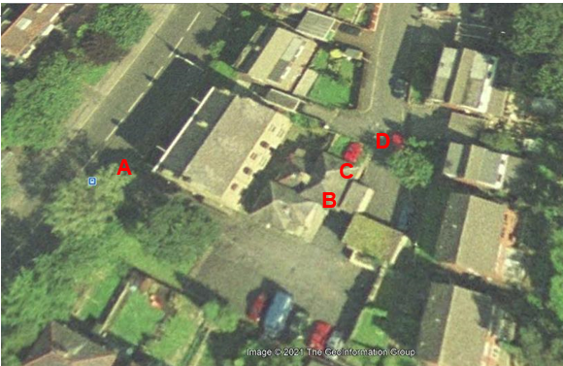
Observations |  | Most of the application route can be seen between point A and point B. The buildings between which the route passes from point B are shown but the route itself cannot be seen. The flagged path between point C and point D can be seen.
Investigating Officer's Comments |  | The application route probably existed in 2000 but by that time the route between point B and point C had been significantly reduced in width by the construction of a garage.
Planning appeal into the planning permission to build properties 1-3 Whitworth Rise | 2010 | The applicant provided a copy of The Planning Inspectorate's decision on application Ref. APP/B2355/A/10/2137171
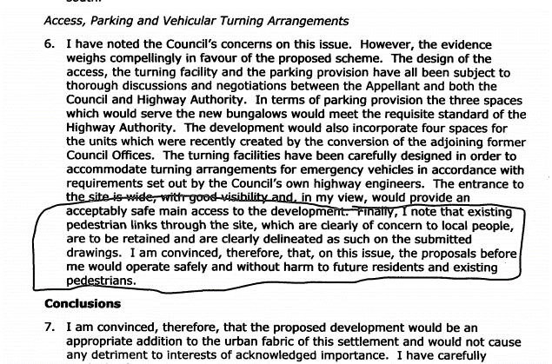
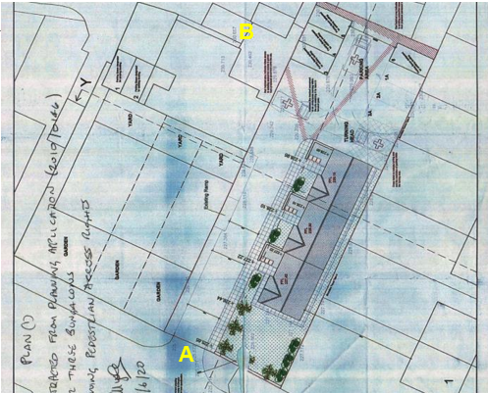
Observations |  | The application to build three small residential properties adjacent to the application route and accessed directly from it was considered by the Planning Inspectorate in 2010.  Reference is specifically made in the Planning Inspector's decision letter to existing pedestrian links through the site and local concern about them. The Planning Inspector does not comment on the nature or legal status of these links but is satisfied, in allowing the appeal, that pedestrian links will not be harmed by the development and that pedestrian links were clearly delineated on the submitted drawings.  The drawing submitted shows delineated pedestrian access along the front of the three properties to be constructed which then crossed the development site to the boundary of the site towards point B and also south east to another pedestrian link between Acre Street and Stoneyroyd.  The properties were subsequently built although the pedestrian routes marked on the plan were not clearly delineated on the ground when the route was inspected in 2021.
Investigating Officer's Comments |  | Existing use of the application route by pedestrians was specifically referred to in 2010 which concurs with the user evidence submitted in support of the application.
Planning Application 2016/0217 |  | This application is on Rossendale BCs web site and is in respect of the former Citizen Advice Offices. The plan refers to the "garage buildings with access from Stoneyroyd"
Investigating Officer Comments |  | The reference to access to highway concurs with the user evidence submitted in support
Definitive Map Records |  | The National Parks and Access to the Countryside Act 1949 required the County Council to prepare a Definitive Map and Statement of Public Rights of Way.  Records were searched in the Lancashire Records Office to find any correspondence concerning the preparation of the Definitive Map in the early 1950s.
Parish Survey Map | 1950-1952 | The initial survey of public rights of way was carried out by the parish council in those areas formerly comprising a rural district council area and by an urban district or municipal borough council in their respective areas. Following completion of the survey the maps and schedules were submitted to the County Council. In the case of municipal boroughs and urban districts the map and schedule produced, was used, without alteration, as the Draft Map and Statement. In the case of parish council survey maps, the information contained therein was reproduced by the County Council on maps covering the whole of a rural district council area. Survey cards, often containing considerable detail exist for most parishes but not for unparished areas.
Observations |  | There is no parish survey map or parish survey cards for Whitworth as the area was a former Urban District Council.
Draft Map |  | The Draft Maps were given a “relevant date” (1st January 1953) and notice was published that the draft map for Lancashire had been prepared. The draft map was placed on deposit for a minimum period of 4 months on 1st January 1955 for the public, including landowners, to inspect them and report any omissions or other mistakes. Hearings were held into these objections, and recommendations made to accept or reject them on the evidence presented.
Observations |  | The application route was not shown on the Draft Map and there were no formal objections or other comments about its omission.
Provisional Map |  | Once all representations relating to the publication of the draft map were resolved, the amended Draft Map became the Provisional Map which was published in 1960, and was available for 28 days for inspection. At this stage, only landowners, lessees and tenants could apply for amendments to the map, but the public could not. Objections by this stage had to be made to the Crown Court.
Observations |  | The application route was not shown on the Provisional Map and there were no formal objections or other comments about its omission.
The First Definitive Map and Statement |  | The Provisional Map, as amended, was published as the Definitive Map in 1962.
Observations |  | The application route is not shown on the First Definitive Map and Statement
Revised Definitive Map of Public Rights of Way (First Review) |  | Legislation required that the Definitive Map be reviewed, and legal changes such as diversion orders, extinguishment orders and creation orders be incorporated into a Definitive Map First Review. On 25th April 1975 (except in small areas of the County) the Revised Definitive Map of Public Rights of Way (First Review) was published with a relevant date of 1st September 1966. No further reviews of the Definitive Map have been carried out. However, since the coming into operation of the Wildlife and Countryside Act 1981, the Definitive Map has been subject to a continuous review process.
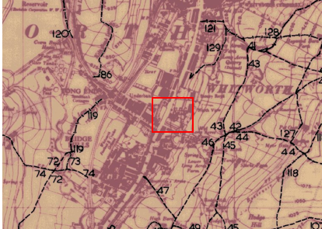
Observations |  | The application route is not shown on the Revised Definitive Map and Statement of Public Rights of Way (First Review).
Investigating Officer's Comments |  | From 1953 through to 1966 there is no indication that the application route was considered to be public by the Surveying Authority, Town Council and public at large due to the extensive consultation process that lasted until 1975 when the Definitive Map of Public Rights of Way (First Review) was actually published.
Highway Adoption Records including maps derived from the '1929 Handover Maps' | 1929 to present day | In 1929 the responsibility for district highways passed from rural district councils to the county council. For the purposes of the transfer, public highway 'handover' maps were drawn up. These were based on existing Ordnance Survey maps and edited to mark those routes that were public. However, they suffered from several flaws – most particularly, if a right of way was not surfaced it was often not recorded.  A right of way marked on the map is good evidence but many public highways that existed both before and after the handover are not marked. In addition, the handover maps did not have the benefit of any sort of public consultation or scrutiny which may have picked up mistakes or omissions.  Both within and outside the rural districts there were later highway maintenance sheets, as shown, although not all are still available.  The county council is now required to maintain, under section 31 of the Highways Act 1980, an up to date List of Streets showing which 'streets' are maintained at the public's expense. Whether a road is maintainable at public expense or not does not determine whether it is a highway or not.
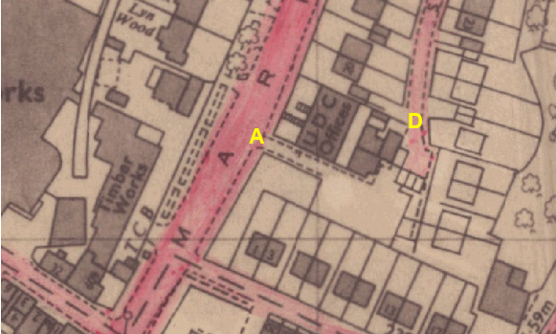
Observations |  | The application route is not recorded as a publicly maintainable highway on the county council's maintenance sheets. Stoneyroyd is adopted. The dedication agreement is not available at present.
Investigating Officer's Comments |  | The fact that the route is not recorded as a publicly maintainable highway does not mean that it does not carry public rights of access so no inference can be drawn.
Highway Stopping Up Orders | 1835 - 2014 | Details of diversion and stopping up orders made by the Justices of the Peace and later by the Magistrates Court are held at the County Records Office from 1835 through to the 1960s. Further records held at the County Records Office contain highway orders made by Districts and the County Council since that date.
Observations |  | No legal orders relating to the creation, diversion or extinguishment of public rights have been found.
Investigating Officer's Comments |  | If public rights are found to exist along the application route they do not appear to have been subsequently diverted or extinguished by a legal order.
Statutory deposit and declaration made under section 31(6) Highways Act 1980 |  | The owner of land may at any time deposit with the County Council a map and statement indicating what (if any) ways over the land he admits to having been dedicated as highways. A statutory declaration may then be made by that landowner or by his successors in title within ten years from the date of the deposit (or within ten years from the date on which any previous declaration was last lodged) affording protection to a landowner against a claim being made for a public right of way on the basis of future use (always provided that there is no other evidence of an intention to dedicate a public right of way).  Depositing a map, statement and declaration does not take away any rights which have already been established through past use. However, depositing the documents will immediately fix a point at which any unacknowledged rights are brought into question. The onus will then be on anyone claiming that a right of way exists to demonstrate that it has already been established. Under deemed statutory dedication the 20 year period would thus be counted back from the date of the declaration (or from any earlier act that effectively brought the status of the route into question).
Observations |  | There are no Highways Act 1980 Section 31(6) deposits lodged with the County Council for the area over which the application route runs.
Investigating Officer's Comments |  | There is no indication by a landowner under this provision of non-intention to dedicate public rights of way over his land.
Photographs of the route submitted by the applicant
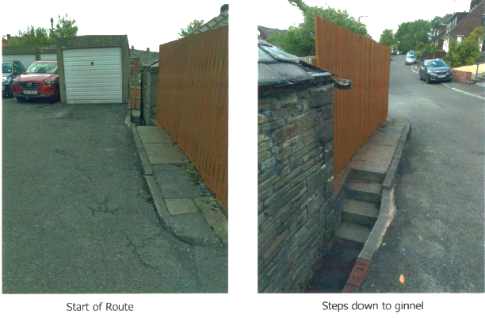
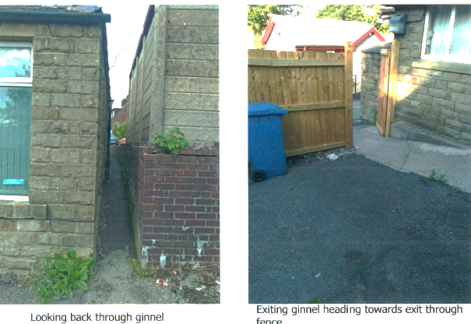
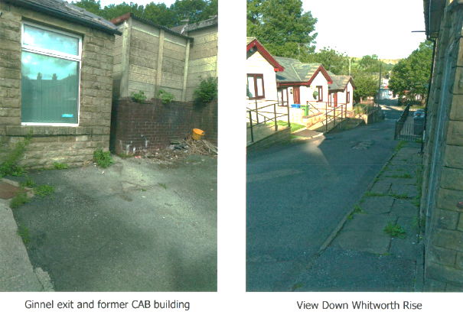
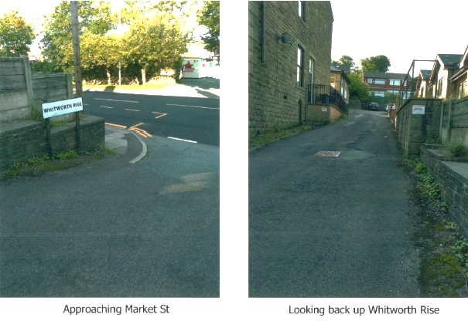

Observations |  | The applicant submitted a number of undated photographs taken to show the route applied for. When the route was inspected by the Investigating Officer in 2021 the route appeared to be the same as is shown on the photographs with the exception of the photograph showing he fence and gate erected in 2020 across the route which has now been removed.
Investigating Officer's Comments |  | The photographs assist in confirming the route applied for by the applicant but provide no evidence regarding the legal status of the route.

The affected land is not designated as access land under the Countryside and Rights of Way Act 2000 and is not registered common land.

Summary

The map and documentary evidence confirm the existence of what appeared to be an accessible route between point A and point D since the 1890s.

However, the 'route' appears to have been originally built in the context of access to a number of properties and there is no suggestion of the existence of a through route until Stoneyroyd and the houses located along it were built in the 1960s. The earliest map confirming the existence of a through route was the 1:2500 OS map revised and published in 1970.

At some point between 1970 and 2000 the garages at the southern end of Stoneyroyd were built but access was retained from Stoneyroyd through to Market Street via the application route – albeit via a very narrow path between points B-C-D.

A Planning appeal determined in 2010 for the development of land crossed by the application route makes reference to pedestrian use of a route through the site consistent with the application route.

The application is based on a substantial body of user evidence which is detailed below and in summary, this user evidence – dating from the late 1960s onwards - is supported by the map and photographic evidence considered above and the Investigating Officer found nothing to suggest that the route could not – or was not in use throughout the years referred to in the user evidence.

Head of Service – Legal and Democratic Services Observations

Landownership

The application route crosses land in private ownership from point A to C but for a very short section at point B, which is unregistered. From point C to D the application route crosses land which is unregistered.

Information from the Applicant

The applicant submitted map and documentary evidence in addition to 17 user evidence forms to support the application. The map and documentary evidence has been considered above. The 17 user evidence forms, recording use by 18 users, will be summarised below.
Duration of Use

The user evidence forms collectively provide evidence of use going back as far as 1966 and up to 2020 when the application to record the right of way was made.

20+ Years including the years 2000 to 2020 | 1-19 Years
16 | 2

Frequency of Use

The majority of the 18 users stated that they used the route weekly or daily, all users recorded their use as on foot.

Daily | Weekly | 5 times per week
12 | 5 | 1

Reasons for Use

The majority of users noted using the route to access shops and services in the town including the medical centre and chemist and the bus stop for onward transport. 3 noted use for please and 2 noted use for dog walking.

Other Users of the Route

All 18 users stated that they had seen others using the route on foot.

Consistency of the Route

All 18 users recorded that the application route has always followed the same route. One did note it had narrowed over the years.

The route width was generally recorded as varying from 0.5 metres wide at its narrowest to a width of 6.7 metres at its widest. 4 users recorded this greater width as being only 5 metres.

1 user stated that the route width varied, being 1 metre at its narrowest. Another gave a width of 29 inches or 73 cms. Another user specified that the route was 500mm wides at its narrowest and another gave the varying widths as 2.5 feet to 6.7 metres.

Unobstructed Use of the Route

None of the 18 users recorded any stiles along the route, 1 gave the answer 'unknown'. Gates were recorded by 2 users; these being installed in part of the fencing which prompted the submission of this application. 1 user again answered 'unknown' to the question regarding gates and another replied with 'N/A'.

There was a general consensus regarding the obstruction of the route with a majority of users noting two fences one erected roughly at point B on the committee plan around 1st May 2020 and another erected to block the ginnel roughly at point C on the committee plan, this being erected around 6th June 2020.

Only 2 users did not recollect these fences replying 'unknown' and 'N/A' respectively.

Of the 18 users 16 stated that barriers had prevented them from using the route with most specifying the fence erected to block the ginnel as being the cause of the obstruction.

Many users recorded being stopped or turned back but this related to the barriers/fencing erected across the route, no one recorded being stopped or turned back by other causes.

Most users did not recollect signs/notices along the route stating it was not public, nor did they record being told that it was not public. 1 user provided no response to these questions.

2 users did record that neighbours were told by developers that the ginnel would be closed and 2 recorded that neighbours had also been prevented from using the route by the obstructions.

Information from Others

BT Openreach advised that they do have apparatus in the area.

Information from the Landowner

The owners of Whitworth Rise responded to consultation to confirm their land ownership and stating that they could not see any reason to object. They noted that they planned to erect a remotely controlled electronic vehicle barrier for ‘resident vehicle car parking’ which would leave space for pedestrian access.

Conclusion

The application is that the route A-B-C-D has already become a footpath in law and should be recorded on the Definitive Map and Public Rights of Way.

There is no express dedication in this matter therefore Committee should consider on balance, whether there is sufficient evidence from which to have dedication inferred at common law from all the circumstances or for the criteria in section 31 Highways Act 1980 for a deemed dedication to be satisfied based on sufficient twenty years "as of right" use to have taken place ending with this use being called into question.

Firstly, looking at whether dedication could be inferred at common law; for there to be inferred dedication, the evidence must show clear intention on the part of the landowner(s) to dedicate the route as a public right of way. Committee is advised to consider whether the evidence presented within this report from the various maps, and other documentary evidence coupled with the evidence on site and user evidence indicates that it can reasonably be inferred that in the past the landowner(s) intended to dedicate the route as a public right of way. Committee must consider whether there is sufficient evidence of the intention to create the actual route being considered in this report.

The Head of Service – Planning and Environment has considered the historical map and documentary evidence and concluded that while it is clear that an accessible route A-B has existed since the 1890's, there is no suggestion of the existence of a through route until Stoneyroyd and the houses located along it were built. The OS map dated 1970 is the only map as evidence to show evidence of a through route from A-D from the 1970's. There is also a plan from circa 1970. The access onto Stoneyroyd initially was wide but within a few years had been narrowed between a new garage and existing building.

The section B-C of the route as applied for and in existence on the ground today was formed as a result of the garage being erected at the time the development was being concluded. Steps were put in on the route. The garage is in one of the property titles on Stoneyroyd. A planning application in 2010 made reference to a pedestrian use of a route through the site consistent with the application route. The aerial photographs also provide some assistance in relation to the route but only from 2000 onwards. A planning application in 2016 also refers to it being an access from Stoneyroyd. Part of the route is unregistered, and the remainder is owned by different land owners. From looking at the user evidence it would appear that there has never been any clear action by owners to prevent use by the public (prior to the calling into question that triggered this application) and use by the public has continued for many years such that on balance there may be sufficient evidence from which to infer dedication at common law of this route from all the circumstances.

Secondly looking at whether there is deemed dedication under section 31 Highways Act 1980 – in order to satisfy the criteria for s31 there must be sufficient evidence of use of the application route by the public, as of right (without force, secrecy or permission) and without interruption, over the 20 year period immediately prior to its status being brought into question, in order to raise a presumption of dedication. The presumption may be rebutted if there is sufficient evidence that there was no intension on the part of the landowner during this period to dedicate the route as a public right of way.

In this matter, the evidence indicates that the route was obstructed in 2020 by the erection of fencing and gates at points B and C in May and June 2020 which called the route into question and prompted the submission of this application. Therefore the 20 year period under consideration for the purposes of establishing deemed dedication would be from 2000 – 2020. The applicant has provided evidence from 18 users (via 17 user evidence forms) in support of the application which refer to regular use of the route from as early as 1966 with the majority of the 18 users stating that they used the route weekly or daily on foot. All 18 users recorded that the application route has always followed the same course and none of the users refer to having seen signs or notices along the route advising that the route was not public.

Committee will note that the owners of Whitworth Rise have been consulted, and have not submitted an objection.

In conclusion, taking all of the evidence into account, Committee on balance may consider that the provisions of section 31 Highways Act 1980 can be satisfied. Committee may also consider that it can be reasonably alleged that there is sufficient evidence from which to infer dedication of a public footpath at common law.

Committee is therefore advised to accept the application, that an Order be made and as it is on balance sufficient evidence such that the higher test can be met that the Order be promoted to confirmation.

Risk management

Consideration has been given to the risk management implications associated with this claim. The Committee is advised that the decision taken must be based solely on the evidence contained within the report, and on the guidance contained both in the report and within Annex 'A' included in the Agenda Papers. Provided any decision is taken strictly in accordance with the above then there is no significant risks associated with the decision making process.

Local Government (Access to Information) Act 1985

List of Background Papers

Paper | Date | Contact/Directorate/Tel
All documents on File Ref: 804-643 |  | Simon Moore, 01772 531280, County Secretary and Solicitors Group
Reason for inclusion in Part II, if appropriate

N/A

The Ordnance Survey (OS) has produced topographic maps at different scales (historically one inch to one mile, six inches to one mile and 1:2500 scale which is approximately 25 inches to one mile). Ordnance Survey mapping began in Lancashire in the late 1830s with the 6-inch maps being published in the 1840s. The large scale 25-inch maps which were first published in the 1890s provide good evidence of the position of routes at the time of survey and of the position of buildings and other structures. They generally do not provide evidence of the legal status of routes, and carry a disclaimer that the depiction of a path or track is no evidence of the existence of a public right of way.

